**Project Design Phase-II**

**Data Flow Diagram & User Stories**

| Date | 17 NOVEMBER 2022 |
| --- | --- |
| Team ID | **PNT2022TMID48112** |
| Project Name | Personal Assistance for Seniors Who Are Self Reliant. |
| Maximum Marks | 4 Marks |

# Dataflow Diagram:

**Start**

* Initialisation

## Step 1

* Data Fed
* Reamind on the time to take

medication with voice command Step 3

* + Keep Track on amount of medicine remains
* Send SMS to went medicine is needed

# End

## Step 2

Step 4

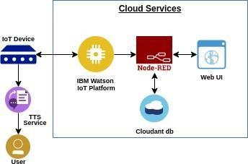

**Technical Architecture:**

# User Stories

| **User Type** | **Functional**  **Requirement (Epic)** | **User**  **Story Number** | **User Story / Task** | **Acceptance criteria** | **Priority** | **Release** |
| --- | --- | --- | --- | --- | --- | --- |
| Customer (citizen) | Registration | USN-1 | As a user, I can register for the application by confirming OTP and  access manually | I can access my account . | High | Sprint-1 |
| Customer (Doctor) | User Requirements | USN-2 | As a user, I want to monitor patients heartbeat 24/7. | I can receive  confirmation email & click confirm. | High | Sprint-1 |
| Customer (Care takers) | Confirmations | USN-3 | As a user, I can register and confirm through e-mail OTP. | I can register & access the dashboard with Facebook Login. | Low | Sprint-2 |
| Customer  (Elderly people) | Payment options | USN-4 | As a user, I can pay through Cash  on Delivery or else with Credit/Debit card. | I can register or pay  through login Dashboard. | Medium | Sprint-1 |
| Administrato r | Dashboard | USN-5 | As a user, I can log into the application by entering mail and  password. | I want to access customer Health and  save the Data 24/7. | High | Sprint-1 |